**The best AI productivity tools by category**

* Chatbots ([ChatGPT](https://zapier.com/blog/best-ai-productivity-tools/#chatgpt), [Claude](https://zapier.com/blog/best-ai-productivity-tools/#claude), [Meta AI](https://zapier.com/blog/best-ai-productivity-tools/#meta), [Zapier Agents](https://zapier.com/blog/best-ai-productivity-tools/#zapier-central))
* Search engines ([Perplexity](https://zapier.com/blog/best-ai-productivity-tools/#perplexity), [Google AI Overviews](https://zapier.com/blog/best-ai-productivity-tools/#google-aio), [Arc Search](https://zapier.com/blog/best-ai-productivity-tools/#arc))
* Content creation ([Jasper](https://zapier.com/blog/best-ai-productivity-tools/#jasper), [Anyword](https://zapier.com/blog/best-ai-productivity-tools/" \l "anyword" \t "_self), [Writer](https://zapier.com/blog/best-ai-productivity-tools/#writer))
* Grammar checkers and rewording tools ([Grammarly](https://zapier.com/blog/best-ai-productivity-tools/#grammarly), [Wordtune](https://zapier.com/blog/best-ai-productivity-tools/" \l "wordtune" \t "_self), [ProWritingAid](https://zapier.com/blog/best-ai-productivity-tools/" \l "prowritingaid" \t "_self))
* Video creation and editing ([Runway](https://zapier.com/blog/best-ai-productivity-tools/#runway), [Descript](https://zapier.com/blog/best-ai-productivity-tools/#descript), [Wondershare Filmora](https://zapier.com/blog/best-ai-productivity-tools/" \l "wondershare-filmora" \t "_self))
* Image generation ([DALL·E 3](https://zapier.com/blog/best-ai-productivity-tools/#dalle2), [Midjourney](https://zapier.com/blog/best-ai-productivity-tools/#midjourney), [Ideogram](https://zapier.com/blog/best-ai-productivity-tools/#ideogram))
* Social media management ([FeedHive](https://zapier.com/blog/best-ai-productivity-tools/" \l "feedhive" \t "_self), [Vista Social](https://zapier.com/blog/best-ai-productivity-tools/#vista-social), [Buffer](https://zapier.com/blog/best-ai-productivity-tools/#buffer))
* Voice and music generation ([ElevenLabs](https://zapier.com/blog/best-ai-productivity-tools/" \l "elevenlabs" \t "_self), [Suno](https://zapier.com/blog/best-ai-productivity-tools/#suno), [AIVA](https://zapier.com/blog/best-ai-productivity-tools/#aiva))
* Knowledge management and AI grounding ([Mem](https://zapier.com/blog/best-ai-productivity-tools/#mem), [Notion AI Q&A](https://zapier.com/blog/best-ai-productivity-tools/#notion), [Personal AI](https://zapier.com/blog/best-ai-productivity-tools/#personal))
* Task and project management ([Asana](https://zapier.com/blog/best-ai-productivity-tools/#asana), [Any.do](https://zapier.com/blog/best-ai-productivity-tools/#anydo), [BeeDone](https://zapier.com/blog/best-ai-productivity-tools/" \l "beedone" \t "_self))
* Transcription and meeting assistants ([Fireflies](https://zapier.com/blog/best-ai-productivity-tools/#fireflies), [Avoma](https://zapier.com/blog/best-ai-productivity-tools/" \l "avoma" \t "_self), [tl;dv](https://zapier.com/blog/best-ai-productivity-tools/" \l "tldv" \t "_self))
* Scheduling ([Reclaim](https://zapier.com/blog/best-ai-productivity-tools/#reclaim), [Clockwise](https://zapier.com/blog/best-ai-productivity-tools/#clockwise), [Motion](https://zapier.com/blog/best-ai-productivity-tools/#motion))
* Email ([Shortwave](https://zapier.com/blog/best-ai-productivity-tools/#shortwave), [Microsoft Copilot Pro for Outlook](https://zapier.com/blog/best-ai-productivity-tools/#microsoft-copilot-outlook), [Gemini for Gmail](https://zapier.com/blog/best-ai-productivity-tools/#gemini-gmail))
* Slide decks and presentations ([Tome](https://zapier.com/blog/best-ai-productivity-tools/#tome), [Beautiful.ai](https://zapier.com/blog/best-ai-productivity-tools/#beautifulai), [Slidesgo](https://zapier.com/blog/best-ai-productivity-tools/" \l "slidesgo" \t "_self))
* Resume builders ([Teal](https://zapier.com/blog/best-ai-productivity-tools/#teal), [Enhancv](https://zapier.com/blog/best-ai-productivity-tools/" \l "enhancv" \t "_self), [Kickresume](https://zapier.com/blog/best-ai-productivity-tools/" \l "kickresume" \t "_self))
* Automation ([Zapier](https://zapier.com/blog/best-ai-productivity-tools/#zapier))
* [Other AI productivity tools](https://zapier.com/blog/best-ai-productivity-tools/#other)

## 1. AI chatbots

The best place to start is the category that brought AI to the mainstream. AI chatbots allow you to chat with an [AI large language model](https://zapier.com/blog/best-llm), letting you ask questions and get answers in a conversational style. The best chatbots use advanced reasoning and logic, write code, and make mathematical calculations.

Take a look at the full list of chatbots in our article on the [best AI chatbots](https://zapier.com/blog/best-ai-chatbot/).

### ChatGPT

[ChatGPT](https://chat.openai.com/) is the current industry leader, and the first chatbot that set the scene on fire. Now powered by GPT-4o, 4o-mini and the o1 reasoning model, it's surprisingly flexible and very easy to use. Learn [how to use ChatGPT](https://zapier.com/blog/how-to-use-chatgpt/), understand [how it works](https://zapier.com/blog/how-does-chatgpt-work/), and discover how to use it to [write marketing copy](https://zapier.com/blog/chatgpt-marketing-writing/), [do market research](https://zapier.com/blog/chatgpt-market-research/), or [write sales emails](https://zapier.com/blog/chatgpt-sales-emails/).

When you [connect ChatGPT to Zapier](https://zapier.com/apps/chatgpt/integrations/), you can [automate ChatGPT](https://zapier.com/blog/automate-chatgpt/), so you can access the power of the AI chatbot from within any of your favorite apps.

### Send prompts to ChatGPT for Google Forms responses and add the ChatGPT response to a Google Sheet

[**Try it**](https://zapier.com/webintent/create-zap?template=255609446)

**Google Forms, ChatGPT (OpenAI), Google Sheets**

**Google Forms + ChatGPT (OpenAI) + Google Sheets**

More details

### Create email copy with ChatGPT from new Gmail emails and save as drafts in Gmail

[**Try it**](https://zapier.com/webintent/create-zap?template=1318753)

**Gmail, ChatGPT (OpenAI)**

**Gmail + ChatGPT (OpenAI)**

More details

### Claude

[Anthropic's safe and creative chatbot](https://zapier.com/blog/claude-ai/), [Claude](https://claude.ai/) builds [Artifacts](https://zapier.com/blog/claude-artifacts): it can code simple interactive interfaces, write documents in a separate tab, or even design games for you. Make changes with prompts on the left side of the screen and see them come into shape on the right.

You can [connect Claude to thousands of other apps](https://zapier.com/apps/anthropic-claude/integrations) using Zapier too. Learn more about [how to automate Claude](https://zapier.com/blog/automate-claude/), or get started with one of these pre-made workflows.

### Write AI-generated email responses with Claude and store in Gmail

[**Try it**](https://zapier.com/webintent/create-zap?template=1619720)

**Gmail, Anthropic (Claude)**

**Gmail + Anthropic (Claude)**

More details

### Generate an AI-analysis of Google Form responses and store in Google Sheets

[**Try it**](https://zapier.com/webintent/create-zap?template=1619743)

**Google Forms, Anthropic (Claude), Google Sheets**

**Google Forms + Anthropic (Claude) + Google Sheets**

More details

### Meta AI



[Meta AI](https://www.meta.ai/), available only in the U.S. for now, is the first step toward a bigger integration of AI features across Facebook, Instagram, and WhatsApp. In addition to answering your questions, you can generate images and short animations with a prompt.

Later, you may be able to use [Meta AI](https://zapier.com/blog/llama-meta/) as you browse Meta's social media platforms, generating content and crushing the massive amount of feed data into more digestible insights about your friends and followers.

### Zapier Agents

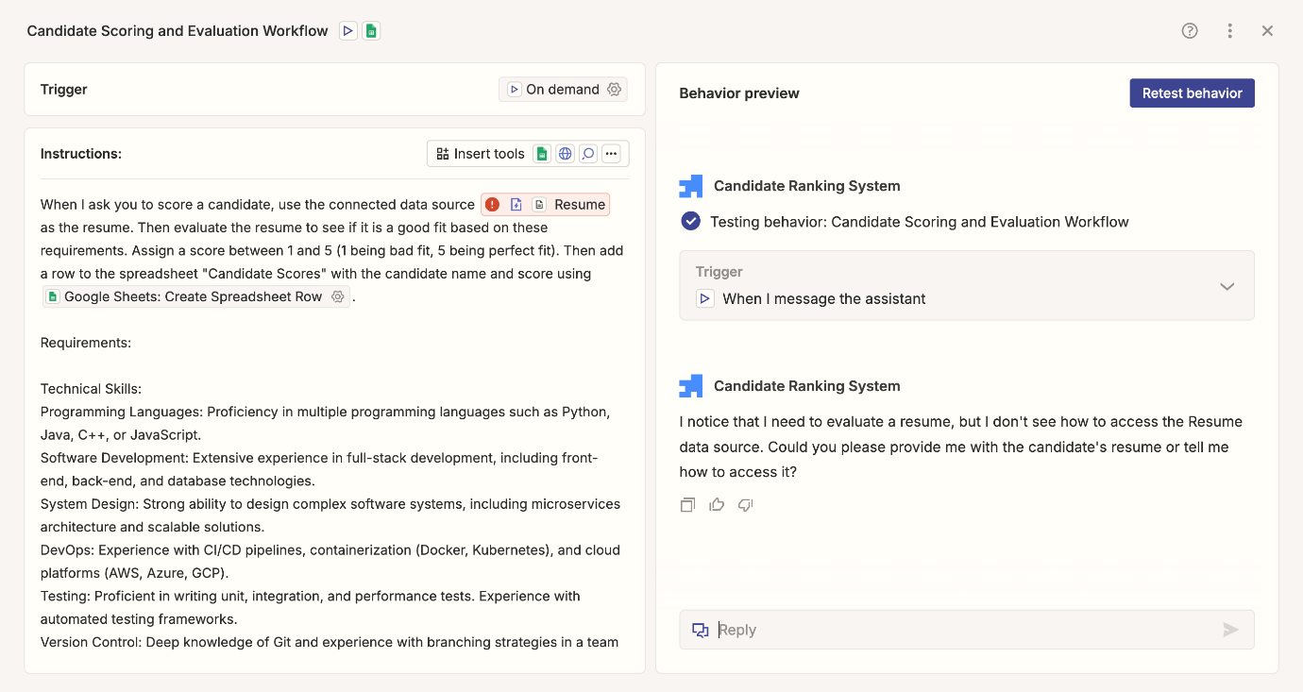

Zapier Agents is an experimental AI workspace where you can teach [AI agents](https://zapier.com/blog/ai-agent/) to work across thousands of apps. But the interface is a chatbot, which means that creating your own AI agent is as simple as using ChatGPT.

Start by giving your agent access to your company's source of truth in apps like HubSpot, Notion, and Airtable. You can ask it about your data as well as all the data in your apps—and data sources will sync automatically.

And you can train your agents to work even while you're not there: tell your agent what to do when it's triggered, how to process or summarize data, and which actions it should take, all without writing a line of code. These agents are like mini-teammates who help you with specific tasks, like analyzing your spreadsheets, searching the web, or drafting responses to customers.

It's AI chat, automation, and data analysis all in one place. [Learn more about Zapier Agents](https://zapier.com/blog/zapier-central-guide/), and then get started for free.

**2. AI search engines**

Hallucinations are one of the biggest issues with AI. To counter this risk, some tools include web searches into their apps, using the results as sources to support the AI-generated answer. And that's an AI search engine in a nutshell.

Get the full tour in our article on [the best AI search engines](https://zapier.com/blog/best-ai-search-engine/).

**Perplexity**

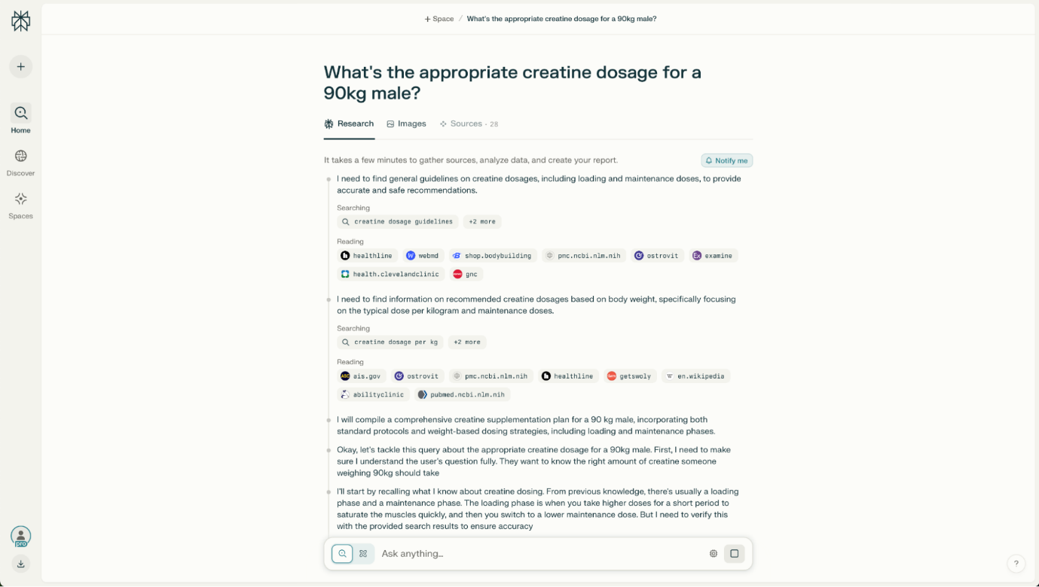

Leading the pack, [Perplexity](https://www.perplexity.ai/) is attracting a lot of attention due to its high-quality answers, great quoting of sources, and staying on topic even as you ask follow-up questions. It uses a combination of Google's, Bing's, and proprietary ranking signals to decide which results are best to base the AI response on. It's really good to use alongside a classic Google search if you're digging into tricky topics—I'm still amazed by the niche things I found while researching with Perplexity. Curious? [Read Zapier's Perplexity full guide here](https://zapier.com/blog/perplexity-ai/).

Because [Perplexity integrates with Zapier](https://zapier.com/apps/perplexity/integrations), you can tap into always-on research and route answers to all your other business tools, automatically. Learn more about [how to automate Perplexity](https://zapier.com/blog/automate-perplexity/), or get started with one of these pre-made templates.

**Send weekly AI-generated emails using Perplexity and Email by Zapier**

[**Try it**](https://zapier.com/webintent/create-zap?template=255644934)

**Schedule by Zapier, Perplexity, Email by Zapier**

**Schedule by Zapier + Perplexity + Email by Zapier**

More details

**Complete chats in Perplexity when new emails arrive in Microsoft Outlook**

[**Try it**](https://zapier.com/webintent/create-zap?template=255633294)

**Microsoft Outlook, Perplexity**

**Microsoft Outlook + Perplexity**

More details

**Google AI Overviews**

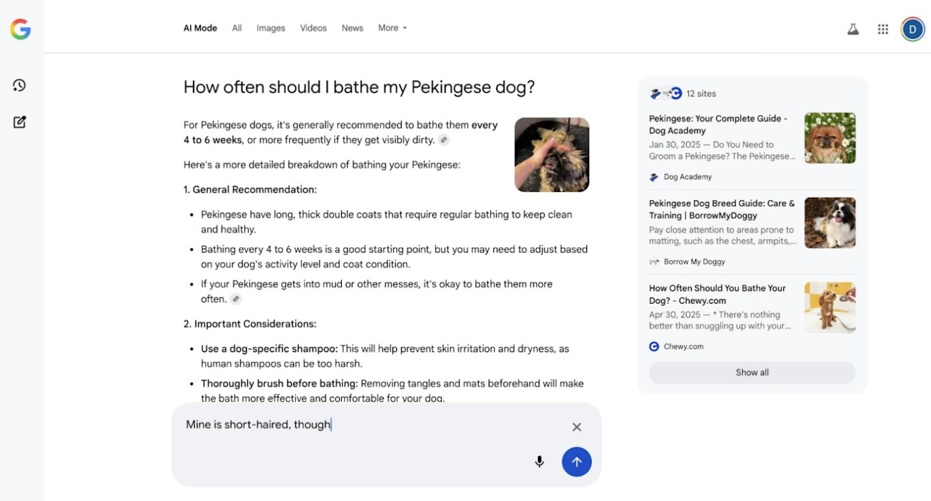

You might've already noticed this when using Google Search lately: in addition to the list of search results, you're now getting an [AI-generated overview](https://zapier.com/blog/google-ai-overviews/) of the top ones. Google's selection of sources to include is hit or miss at the moment, so please check everything before using any information. Still, the generated answer offers a good overview before starting a deep-dive.

**Arc Search**

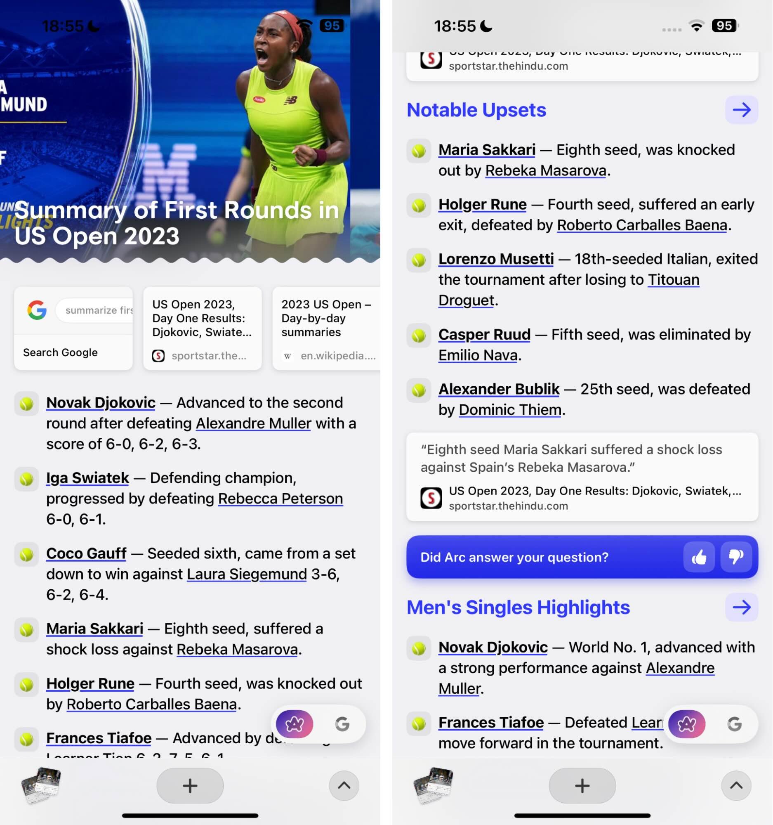

Part of the [Arc Browser](https://zapier.com/blog/arc-browser-review/) project, [Arc Search](https://arc.net/blog/arc-search) brings AI features into your search experience: enter your question and tap *Browse for me* to begin. Arc will grab the top results, break it down in sections, and start summarizing the source content into a structured answer. Toggle between the AI-generated results and the classic Google search page using the control at the bottom right of the screen. iOS and iPadOS only for now.

**3. AI apps for content creation**

Entire movies have been made about writer's block. These apps are here to break it. By entering your prompts, starting from templates, or using recipes, you can use AI models as a co-writer, helping you put together first drafts faster.

Browse all the possibilities in our list of the [best AI writing generators](https://zapier.com/blog/best-ai-writing-generator/).

**Jasper**

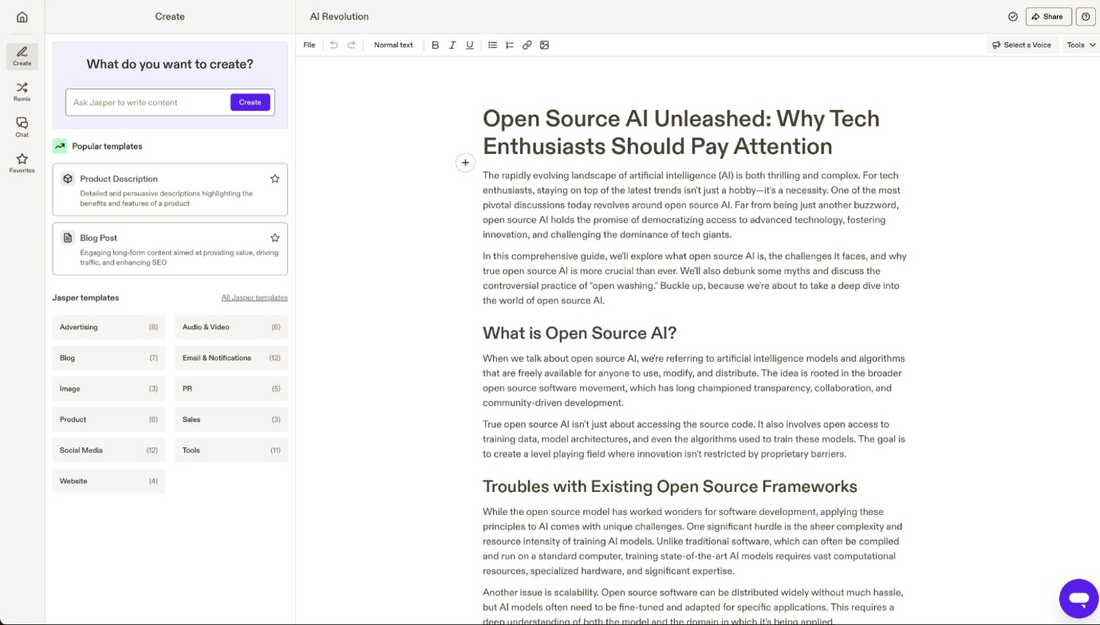

[Jasper](https://www.jasper.ai/) is a powerful [AI content creation platform](https://zapier.com/blog/jasper-ai/), favoring users who need a high volume of content. It packs dozens of templates to help you get started, connects to the internet to find research and sources, and also lets you generate images with AI. All your content creation needs are covered here.

You can also [connect Jasper to thousands of other apps](https://zapier.com/apps/jasper/integrations) using Zapier. Learn more about [how to automate Jasper](https://zapier.com/blog/automate-jasper/) or try one of the pre-built workflows below.

**Update product descriptions from Google Forms responses and update in Shopify**

[**Try it**](https://zapier.com/webintent/create-zap?template=1420836)

**Google Forms, Jasper, Shopify**

**Google Forms + Jasper + Shopify**

More details

**Run Jasper commands to create content outlines based on a brief**

[**Try it**](https://zapier.com/webintent/create-zap?template=1420022)

**Asana, Jasper, Google Docs**

**Asana + Jasper + Google Docs**

More details

**Read more:**[Jasper vs. ChatGPT](https://zapier.com/blog/jasper-vs-chatgpt)

**Anyword**

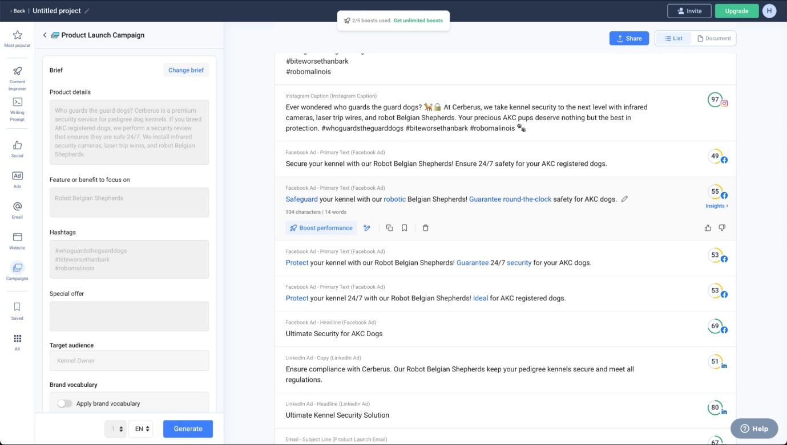

[Anyword](https://anyword.com/) helps marketers create content by breaking the generation process down step by step. First, you add your prompt to generate a few titles. Then, you can pick your favorite and see a generated outline. Once you tweak that outline to what you want to cover, you can move forward to generating the final piece.

**Writer**

Big businesses can't afford missteps. A misplaced fact or an inaccurate claim can hurt brands, tank reputations, and take things to court. Where other LLMs tread gray areas, [Writer](https://writer.com/) offers their proprietary LLMs and plenty of tools to make sure your content stays true. On top of it, [Writer](https://zapier.com/blog/writer-ai-enterprise-generative-ai/) will help keep brand voice consistent for teams who collaborate on publishing. That's the productivity boost of AI with fewer risks.

You can [connect Writer to Zapier](https://zapier.com/apps/writer/integrations)—learn more about [how to automate Writer](https://zapier.com/blog/automate-writer/), or get started with one of these templates.

**Repurpose a Facebook post with Writer and add it to your Buffer queue**

[**Try it**](https://zapier.com/webintent/create-zap?template=1536155)

**Facebook Pages, Writer, Buffer**

**Facebook Pages + Writer + Buffer**

More details

**Create social posts from new items in an RSS feed and add them to LinkedIn**

[**Try it**](https://zapier.com/webintent/create-zap?template=1536146)

**RSS by Zapier, Writer, LinkedIn**

**RSS by Zapier + Writer + LinkedIn**

More details

**4. AI apps for text enhancement**

Spell-checking has been around for a long time, but AI is changing the game. Before, it only detected spelling and basic structure errors. Now, it can spot tone and complex language and offer suggestions to make your writing clearer.

Discover all the available apps in our list of the [best grammar checkers](https://zapier.com/blog/best-ai-grammar-checker-rewording-tool/).

**Grammarly**

[Grammarly](https://www.grammarly.com/) is the mainstream spell- and structure-checking app. It's a complete solution that keeps your English on point, lets you adjust your tone, and suggests shortcuts to simplify wordy or complex phrases. It has plenty of extensions and integrations, so you can use it almost anywhere there's a text box. It has basic generative text features, too.

**Wordtune**

[Wordtune](https://www.wordtune.com/) helps you find plenty of wording alternatives to improve your text. When you input the text you want to check, you can easily browse synonyms, ask to rewrite entire sentences, and adapt the suggestions into a final draft.

**ProWritingAid**

[ProWritingAid](https://prowritingaid.com/) is a direct competitor of Grammarly, offering plenty of statistics to help you track grammar, style, and spelling scores. One of the main advantages here is its lifetime plan, helping you leverage all these features without adding a new recurring bill. Find out which is the best for you in our [ProWritingAid vs. Grammarly](https://zapier.com/blog/prowritingaid-vs-grammarly/" \t "_self) comparison.

**5. AI apps for video generation and editing**

While full-blown video generation is still coming together, there's already a set of video tools that leverage AI to enhance video, remove backgrounds accurately, and even paint a few new images into each frame.

For the full list, see our picks for the [best AI video generators](https://zapier.com/blog/best-ai-video-generator/).

**Runway**

[Runway](https://runwayml.com/) is a video magic wand. The new Gen-3 Alpha model is a big step up in AI video generation, making it one of the best commercially available solutions. It has a set of interesting features that helps you generate video with AI, train your own models, and paint parts of frames using text prompts. The learning curve is very rewarding, and the app is growing at a great pace. Be sure to check it out.

**Descript**

[Descript](https://www.descript.com/) transcribes your videos into a script. Then, instead of using a timeline to trim the audio and video tracks, you edit the text script. As you do so, the video gets trimmed automatically. The rest of the editing works in a similar way, cutting the time to edit your talking head videos. Find out how it simplifies your audiovisual workflows [in our walkthrough](https://zapier.com/blog/descript-review/).

**Wondershare Filmora**

[Wondershare Filmora](https://filmora.wondershare.com/) has been around for a long time. Now, it also brings to the table a set of AI features that let you remove backgrounds, denoise low-quality clips, and improve sound quality. All this with the classic [video editing](https://zapier.com/blog/best-video-editing-software/) user experience, so you'll never feel lost.

**6. AI apps for image generation**

An image is worth a thousand words, but you don't need so many to generate a beautiful one with AI. These image generators take a text prompt and deliver the results—and this can be anywhere between mind-blowing to nightmare-inducing. They're both hugely entertaining and highly useful.

Read more about our picks for the [best AI image generators](https://zapier.com/blog/best-ai-image-generator/).

**DALL·E 3**

[DALL·E 3](https://openai.com/dall-e-3) is an image generator by OpenAI, the creators of ChatGPT. It's very simple to use—[it runs in ChatGPT](https://zapier.com/blog/dall-e-3/)—and it produces [interesting results](https://zapier.com/blog/dall-e-examples/), no matter if you've just started [writing image prompts](https://zapier.com/blog/ai-art-prompts/) or are already a master. A great choice to begin exploring the realm of AI image generation.

You can [connect DALL·E to Zapier](https://zapier.com/apps/openai/integrations) to do things like automatically create images from transcripts, chat messages, or any other apps you use. Learn more about how to [automate AI image generation](https://zapier.com/blog/best-ai-image-generator/), or start with one of these examples.

**Create images with DALL.E based on Slack messages and send as a channel message**

[**Try it**](https://zapier.com/webintent/create-zap?template=1197037)

**Slack, OpenAI (GPT-4, DALL-E, Whisper)**

**Slack + OpenAI (GPT-4, DALL-E, Whisper)**

More details

**Create transcripts of audio files with OpenAI's Whisper**

[**Try it**](https://zapier.com/webintent/create-zap?template=1252350)

**Dropbox, ChatGPT (OpenAI)**

**Dropbox + ChatGPT (OpenAI)**

More details

**Midjourney**

[Midjourney](https://www.midjourney.com/app) is impressive. Anything you throw at it generates incredible results—even if sometimes they're slightly off the mark. And while using it within Discord started making sense for me, it's now possible to generate images on your browser as well.

Hit the ground running with our guide for [how to use Midjourney](https://zapier.com/blog/how-to-use-midjourney/), or take a look at [how it compares to DALL·E 3](https://zapier.com/blog/midjourney-vs-dalle/).

**Ideogram**

Image models are famous for their trouble when drawing letters. But [Ideogram](https://ideogram.ai/) got the hang of it: it can generate accurate text whenever you ask for it in a prompt. Apart from that, it generates good-looking images, only slightly behind Midjourney in quality. And if you want additional aesthetic control, try out the image editor. Start playing with the 10 daily free credits—but keep in mind that everything you generate in this free plan is public.

**7. AI apps for social media management**

Keeping your social media channels active is like trying to juggle a dozen balls: new balls come in, old ones drop out, and you have to keep them all in the air at the same time. That's images, videos, text, engaging with your audience, wrapping everything up into reports—and going again consistently.

AI can help: take a look at our list of [the best AI social media management tools](https://zapier.com/blog/best-ai-social-media-management/).

**FeedHive**

Content repurposing is a smart strategy for two reasons. First, it helps your newer audience connect with the lightbulb moments you dropped before they were following you. Second, it eases the pressure of having to create new content from scratch every week. [FeedHive](https://www.feedhive.com/" \t "_blank) includes AI-powered content recycling features, among a vast collection of other tools to make sure you switch the admin hat for creative one.

**Vista Social**

When you're managing four or more channels at once, it's easy to lose track of what's happening. [Vista Social](https://vistasocial.com/) acts as a hub for everything social media, gathering it all in a single place. The AI tools help repurpose content from platform to platform, so you can start writing for LinkedIn but have it ready for Facebook and Instagram, for example.

[Connect Vista Social to Zapier](https://zapier.com/apps/vista-social/integrations) to do even more with your AI tools. Here are some examples to get you started.

**Send Slack channel messages for newly scheduled Vista Social posts**

[**Try it**](https://zapier.com/webintent/create-zap?template=1143139)

**Vista Social, Slack**

**Vista Social + Slack**

More details

**Schedule new posts in WordPress in Vista Social**

[**Try it**](https://zapier.com/webintent/create-zap?template=1143143)

**WordPress, Vista Social**

**WordPress + Vista Social**

More details

**Buffer**

[Buffer](https://zapier.com/blog/how-to-use-buffer/)'s AI features focus on sharpening your message to match the engagement style of each social media platform. As you [create a new post](https://zapier.com/blog/how-to-use-buffer/), the side tab updates with copy matching the channel's requirements, offering ways to further customize the tone and length. It also offers a place where you can note down all your post ideas, so you can quickly expand them with AI and schedule them for publishing.

And when you [connect Buffer to Zapier](https://zapier.com/apps/buffer/integrations), you can automate your social media management even more. Here are some examples, or you can learn more about [how to automate Buffer](https://zapier.com/blog/automate-buffer/).

**Buffer new items in an RSS feed**

[**Try it**](https://zapier.com/webintent/create-zap?template=141)

**RSS by Zapier, Buffer**

**RSS by Zapier + Buffer**

More details

**Share new posts from Ghost to Buffer**

[**Try it**](https://zapier.com/webintent/create-zap?template=50907)

**Ghost, Buffer**

**Ghost + Buffer**

More details

**8. Voice and music generators**

YouTubers and other social media creators sometimes struggle to get original assets for their content. Good thing AI is here to (re)mix everything with [AI voice generators](https://zapier.com/blog/best-ai-voice-generator/) and AI music generators.

**ElevenLabs**

[ElevenLabs](https://elevenlabs.io/) is the flashiest AI voice generator platform on the market. With [high-quality output](https://zapier.com/blog/elevenlabs), a sound effect generator, and over 300 voices—including some of real-world personalities such as Christy Carlson Romano, Disney's Kim Possible—it's easy to see how it got a $1B valuation. Whenever you need clear, engaging voices and don't have the time or budget for working with voice actors, be sure to try it out. [Listen to a sample here](https://cdn.zapier.com/storage/files/6b0400248d094639984f93e57e528008.mp3).

**Suno**

Want to compose a quick hit but don't have time to hang out at the recording studio? Skip everything: enter a prompt, and [Suno](https://suno.com/) will create a song, complete with lyrics, varied musical composition, and an actual voice track. I generated [a song about a flying banana](https://suno.com/song/d0cc7437-0fb4-48ce-bd56-d85cd31d07ec) that would've perfectly blended in a night out in a Spanish island club. Even if you won't use it in the long run, give it a quick try: it's super fun.

**AIVA**

[AIVA](https://www.aiva.ai/) also deals with music, but takes a different approach. Instead of a text prompt, there are three ways you can start generating:

* By picking a style, from epic orchestral to cinematic cyberpunk
* By chord progression
* By uploading an audio reference as inspiration

Once ready, you can edit the result in a timeline editor, adding or removing instrument tracks as you feel your way into the final version.

**9. AI apps for knowledge management and grounding**

AI is also a powerful assistant search tools. When you connect it to your personal data, workspace, or [second brain](https://zapier.com/blog/second-brain-notion-template/), it can find anything you need and put it into a natural language answer. Much better than sifting through your notes for hours, right? This is the gist of grounding: keeping an AI model close to your facts—not up there flying with the [hallucinations](https://zapier.com/blog/ai-hallucinations/).

**Mem**

[Mem](https://mem.ai/) uses AI to tag and connect the notes you take, so you don't have to spend time organizing them. You can just gather bits and pieces of information, store them, and trust that [Mem's AI features](https://zapier.com/blog/mem-ai/) will keep everything connected and organized. When the time comes to search for those notes, you can browse the automatic tags and use the search bar to find all you wrote about each topic that matters to you.

Keep feeding your intelligent second brain by [connecting Mem to Zapier](https://zapier.com/apps/mem/integrations/), improving data transmission and opening up more [automation opportunities](https://zapier.com/blog/automate-mem/). Here are a few examples to get you started.

**Create mems in Mem from new Outlook emails**

[**Try it**](https://zapier.com/webintent/create-zap?template=694397)

**Microsoft Outlook, Mem**

**Microsoft Outlook + Mem**

More details

**Create mems in Mem from new pushed messages in Slack**

[**Try it**](https://zapier.com/webintent/create-zap?template=694209)

**Slack, Mem**

**Slack + Mem**

More details

**Notion AI**

[Notion](https://zapier.com/blog/how-to-use-notion-ai/) is a strong workspace for organizing your knowledge, but even if you're disciplined, important pages will still fall through the cracks. Not anymore with [Notion AI Q&A](https://www.notion.so/product/ai): grounded on your data, it generates answers and points you to the sources, revealing that lost insight you recorded in a meeting years ago.

You can [connect Notion to Zapier](https://zapier.com/apps/notion/integrations) to streamline things even more. Learn more about [how to automate Notion](https://zapier.com/blog/automate-notion/), or try one of these workflows.

**Add new Google Calendar events to databases in Notion**

[**Try it**](https://zapier.com/webintent/create-zap?template=597600)

**Google Calendar, Notion**

**Google Calendar + Notion**

More details

**Create pages in Notion for new tl;dv recordings**

[**Try it**](https://zapier.com/webintent/create-zap?template=1541904)

**tl;dv, Notion**

**tl;dv + Notion**

More details

**Personal AI**

While Mem and Notion focus on notes and documents, [Personal AI](https://www.personal.ai/) focuses on messaging. The data you upload into the app is turned into memory blocks. Then, whenever someone messages you, [your personal AI](https://zapier.com/blog/personal-ai/) generates a reply based on your data: you can edit the details or tap to send it right away. When you feel your AI model knows enough about you, you can turn on AI Autopilot, which will make others feel like they're talking to a ChatGPT-like version of you.

You can help Personal AI learn about you by [connecting it to Zapier](https://zapier.com/apps/personal-ai/integrations) and sending it memories from the apps where you spend the most time. Learn more about [how to automate Personal AI](https://zapier.com/blog/automate-personal-ai/), or get started with one of these workflows.

**Send emails with Personal AI**

[**Try it**](https://zapier.com/webintent/create-zap?template=1562782)

**Gmail, Personal AI**

**Gmail + Personal AI**

More details

**Create a new memory in Personal.ai for new messages posted to a channel in Discord**

[**Try it**](https://zapier.com/webintent/create-zap?template=1213683)

**Discord, Personal AI**

**Discord + Personal AI**

More details

**10. AI task and project management**

When you have a good plan, collaboration and execution are easier. [AI project management](https://zapier.com/blog/ai-project-management) and task management can help getting more clarity on what to do, optimize processes, and help you cross every single task off your list. And there are plenty of [AI project management tools](https://zapier.com/blog/best-ai-project-management-tools/) to help you get there.

**Asana**

A project management heavyweight, [Asana](https://asana.com/) adds a wide range of useful AI-powered features. Smart goals use historical data to come up with better goals for the quarter. It identifies project risks and workflow blockers, so you can tackle trouble before it happens. And it provides answers to anything related to your projects, helping you gain more visibility into what is (or isn't) happening.

You can automate Asana even more by [connecting it to Zapier](https://zapier.com/apps/asana/integrations), so it can talk to thousands of other apps. Learn more about [how to automate Asana](https://zapier.com/blog/automate-asana/), or take a look at these pre-made workflows.

**Create new Asana tasks from new Google Calendar events**

[**Try it**](https://zapier.com/webintent/create-zap?template=1500)

**Google Calendar, Asana**

**Google Calendar + Asana**

More details

**Add new Typeform entries to Asana as tasks**

[**Try it**](https://zapier.com/webintent/create-zap?template=1356)

**Typeform, Asana**

**Typeform + Asana**

More details

**Any.do**

It's natural not to know the entire task lineup of a project. If you have trouble figuring out all the steps to get from zero to complete, [Any.do](https://any.do/) generates tasks for you. Whenever you're writing them down, you can take a look at AI suggestions and click to enlarge your list.

[Connect Any.do to Zapier](https://zapier.com/apps/any-do/integrations) to automate all your task management processes. Read more about [how to automate Any.do](https://zapier.com/blog/automate-anydo/), or check out these pre-made workflows.

**Add new Google Calendar events to Any.do as tasks**

[**Try it**](https://zapier.com/webintent/create-zap?template=63179)

**Google Calendar, Any.do Personal**

**Google Calendar + Any.do Personal**

More details

**Create tasks in Any.do for new ended meetings in Google Calendar**

[**Try it**](https://zapier.com/webintent/create-zap?template=58967)

**Google Calendar, Any.do Personal**

**Google Calendar + Any.do Personal**

More details

**BeeDone**

[BeeDone](https://www.beedone.co/) is a quirky option directed at those of us who need a little excitement to get things done (I'm 100% guilty here). Based on principles put forward by Cal Newport and James Clear (among other productivity greats), the app turns boring tasks into little games, offering rewards whenever you move forward. It keeps track of your habits, offers an AI assistant to guide you, and you can spin the Task Roulette if you feel like tackling a random one from your list.

**11. AI transcription apps and meeting assistants**

Taking notes in meetings may reduce your focus, so why not scrap that activity entirely? AI transcription/meeting assistant apps are great to turn voice into text, letting you browse it later. This will help you be more present in your meetings and, at the same time, be able to thoroughly analyze the transcription later.

Pick your favorite in our lists of the [best transcription apps](https://zapier.com/blog/best-transcription-apps/) and the [best AI meeting assistants](https://zapier.com/blog/best-ai-meeting-assistant/).

**Fireflies**

[Fireflies](https://fireflies.ai/) is great to transcribe all your meetings, tracking the conversation topics along the way. It has its own bot called Fred that can handle summarizing the meeting's contents, generating text, and searching through your history to meet your query.

[Integrate Fireflies with Zapier](https://zapier.com/apps/fireflies/integrations) to connect Fireflies to thousands of other apps. Learn more about [how to automate Fireflies](https://zapier.com/blog/automate-firefliesai/), or get started with one of these pre-made workflows.

**Create Notion database items for new Fireflies.ai meetings.**

[**Try it**](https://zapier.com/webintent/create-zap?template=1211408)

**Fireflies.ai, Notion**

**Fireflies.ai + Notion**

More details

**Create ChatGPT conversations from new Fireflies.ai meetings**

[**Try it**](https://zapier.com/webintent/create-zap?template=1219284)

**Fireflies.ai, ChatGPT (OpenAI)**

**Fireflies.ai + ChatGPT (OpenAI)**

More details

**Read more:**[Fathom vs. Fireflies](https://zapier.com/blog/fathom-vs-fireflies/)

**Avoma**

Transcribing a meeting is just the first step. There's so much more happening above, below, and around the words, and that's what [Avoma](https://www.avoma.com/" \t "_blank) focuses on. It keeps track of speaking stats, such as filler word count, monologues, and talking-to-listening ratios. It records topics people are discussing in your calls, helping you understand what are the pressing issues you should address now. And, to wrap it up, a set of AI scoring tools to help your sales team understand how to improve.

[Connect Avoma to Zapier](https://zapier.com/apps/avoma/integrations) to automate all your meeting workflows—get started with one of these pre-built templates.

**Send Slack messages for new conversations in Avoma**

[**Try it**](https://zapier.com/webintent/create-zap?template=1807335)

**Avoma, Slack**

**Avoma + Slack**

More details

**Create new Notion database items from new Avoma conversations**

[**Try it**](https://zapier.com/webintent/create-zap?template=255613868)

**Avoma, Notion**

**Avoma + Notion**

More details

**tl;dv**

With the zaniest marketing I've seen in a long time, [tl;dv](https://tldv.io/ai-meeting-assistant/" \t "_blank) is turning your remote meeting catch-ups into snappy reads. It keeps all your meetings in the platform, ready to organize into folders. Is there an interesting bit you'd like to highlight? You can create short clips of any meeting to make a point or update your team on anything. And with one of the most generous free plans around, adding [tl;dv](https://zapier.com/blog/tldv-features/" \t "_self) to your productivity arsenal is a no-brainer.

By [connecting tl;dv to Zapier](https://zapier.com/apps/tldv/integrations), you can streamline your meetings. Learn more about [how to automate tl;dv](https://zapier.com/blog/automate-tldv/), or start with one of these examples.

**Create pages in Notion for new tl;dv recordings**

[**Try it**](https://zapier.com/webintent/create-zap?template=1541904)

**tl;dv, Notion**

**tl;dv + Notion**

More details

**Create Google Docs documents from text for new tl;dv transcripts**

[**Try it**](https://zapier.com/webintent/create-zap?template=1574573)

**tl;dv, Google Docs**

**tl;dv + Google Docs**

More details

**12. AI apps for scheduling**

No one loves the back and forth of setting up meetings, or any of the extra work tied to scheduling your work for the day. In an ideal world, you'd just look at your calendar, hop on meetings, and start your tasks at the marked date and time. We're getting closer to that, as AI can already take some trouble out of scheduling your work and your life.

See the full list of the [best AI scheduling assistants](https://zapier.com/blog/best-ai-scheduling/).

**Reclaim**

[Reclaim](http://reclaim.ai/) does a great job protecting your habits, so you never miss your weekly fitness objectives or your reading targets. More than that, it'll defend the time you need to complete important tasks by rearranging your schedule.

**Clockwise**

[Clockwise](https://www.getclockwise.com/) is better for teams, promising to save you one hour per week—and to show you that it works, it'll schedule a one-hour break shortly after you start using it. You can adjust the settings to create your ideal day where work, breaks, and meetings live in harmony.

**Motion**

[Motion](https://www.usemotion.com/) focuses on project management, helping you keep track of all the tasks you still have to complete. By tweaking each [task priority](https://zapier.com/blog/how-to-prioritize/), you'll be telling the AI engine when it should land on the calendar and how to place the other tasks around it.

By [connecting Motion to Zapier](https://zapier.com/apps/motion/integrations), you can automatically create new Motion tasks from Slack messages, emails, and any other tool you use at work. Here are a few examples to get you started, or you can learn more about [automating Motion](https://zapier.com/blog/automate-motion/).

**Create Motion tasks from new saved Slack messages**

[**Try it**](https://zapier.com/webintent/create-zap?template=1393270)

**Slack, Motion**

**Slack + Motion**

More details

**Add new Microsoft To Do tasks to Motion**

[**Try it**](https://zapier.com/webintent/create-zap?template=1399459)

**Microsoft To Do, Motion**

**Microsoft To Do + Motion**

More details

**Read more:** [SkedPal vs. Motion](https://zapier.com/blog/skedpal-vs-motion" \t "_self)

**13. AI apps for email and inbox management**

People spend about one month per year managing their work email inbox—no, [I didn't make this up](https://www.statista.com/statistics/1332517/time-spent-checking-emails-us-users-daily/). With so many messages to follow up on, it can feel like email is driving you away from what really moves your work forward. You can start cutting the admin time here by using an [AI email assistant](https://zapier.com/blog/best-ai-email-assistant) to categorize, generate reply drafts, and keep everything up to date.

**Shortwave**

[Shortwave](https://www.shortwave.com/) offers plenty of AI features in a single app, making it the top dog in the AI email management space right now. In addition to generating emails and summarizing threads—which is the bread and butter of the category—you'll also enjoy scheduling events with natural language and deep inbox search with AI responses. Only works with Gmail accounts for now, but let's hope that changes soon.

**Microsoft Copilot Pro for Outlook**

[Microsoft Copilot](https://copilot.cloud.microsoft/en-us/copilot-pro), the tech giant's AI feature package for the 365 suite, adds a range of cool intelligent tools. [It does the basics](https://zapier.com/blog/microsoft-copilot/) with a couple of useful twists, making it a great email buddy: when summarizing a thread, it offers sources to help you jump to relevant messages; and if you're not sure how your email will land, you can use Coaching by Copilot: the AI will analyze the tone, content, and structure of your communication and offer tips to make it clearer and more empathetic.

Because [Outlook connects to Zapier](https://zapier.com/apps/microsoft-outlook/integrations), you can automate your email and spend even less time in your inbox. Learn more about [how to automate Outlook](https://zapier.com/blog/automate-microsoft-outlook-email-with-zapier/), or get started with one of these pre-built workflows.

**Add Microsoft Outlook events to Google Calendar**

[**Try it**](https://zapier.com/webintent/create-zap?template=4213)

**Microsoft Outlook**

**Microsoft Outlook**

More details

**Add Microsoft Outlook events from new Google Calendar events**

[**Try it**](https://zapier.com/webintent/create-zap?template=4212)

**Google Calendar, Microsoft Outlook**

**Google Calendar + Microsoft Outlook**

More details

**Gemini for Gmail**

Google is in the game with their [Gemini add-on](https://workspace.google.com/solutions/ai/), unlocking AI features [across its Workspace suite](https://zapier.com/blog/gemini-for-workspace/). Click the star icon at the top right of the screen and dive in. Gemini offers contextual actions in your inbox, summarizing your top threads and keeping track of orders. When opening an email, you can summarize the entire conversation and start generating a reply from the side tab. And if your response needs a bit more context, you can quickly retry with Google Search to use the search results as sources.

And by [connecting Gmail to Zapier](https://zapier.com/apps/gmail/integrations), you can streamline your inbox even more. Here are some templates to inspire you, or you can read more about [how to automate Gmail](https://zapier.com/blog/automate-gmail-with-zapier/).

**Save new Gmail emails matching certain traits to a Google Spreadsheet**

[**Try it**](https://zapier.com/webintent/create-zap?template=2618)

**Gmail, Google Sheets**

**Gmail + Google Sheets**

More details

**Save new Gmail attachments to Google Drive**

[**Try it**](https://zapier.com/webintent/create-zap?template=192)

**Gmail, Filter by Zapier, Google Drive**

**Gmail + Filter by Zapier + Google Drive**

More details

**14. AI apps for presentations and slide decks**

Your magnetic stage presence is what people came for, but they stayed because of your beautiful slide deck. Clean and beautiful slides support your performance, keep your audience engaged, and help you drive in the points that you're making. The problem? Creating a solid slide deck can take a decent chunk of time, especially if you're starting from scratch. Can AI help?

Read more about presentation software with our picks for the [best PowerPoint alternatives](https://zapier.com/blog/best-powerpoint-alternatives/).

**Tome**

AI can be unpredictable, but [Tome](https://beta.tome.app/) is refreshing: it just *works*. Punch in your prompt—or choose from a library of templates covering use cases from sales enablement to company pitches. Tome generates an outline to make sure it's got the gist. Once you approve, it moves forward to creating the presentation. You can edit with simple controls that feel like a combination between Notion and a standard deck editor.

**Beautiful.ai**

[Beautiful.ai](http://beautiful.ai/) delivers on its name's promise. It simplifies the process of putting together a beautiful slide deck, with all the layouts and styles figured out. Pick the colors, find royalty-free images in the library, and start putting together your presentation. If you have data that changes frequently, you can update it by using sliders and tables. The values will then change dynamically on the presentation.

**Slidesgo**

[Slidesgo](https://slidesgo.com/) will let you pick the topic, writing tone, and a general template. AI generates the whole presentation for you, and from there, you can add your own content, customize each slide, and use AI to write, generate images, or generate a new slide.

**15. AI apps for building a resume**

Looking for a job is a job in itself. Searching for open positions, crafting tailored CVs, and wowing your target companies with sharp cover letters can take up plenty of time. AI has answers for every bit of this journey, helping you ease into the process and pivot to the next phase of your career.

Read more in this roundup of the [best AI resume builders](https://zapier.com/blog/best-resume-builder/).

**Teal**

[Teal](https://www.tealhq.com/tools/resume-builder) focuses on your objectives. When you sign up for the app, it asks about your experience, your target position, and how much you'd like to earn. To finish the process, just add how long you have to get the new job or move up from the current one. The platform will keep track of these core metrics so you can keep your eye on the ball. Then, add your CV, round up the opportunities you're applying for, and Teal will use AI to help you understand how your skills match the jobs—and offer ways to help you edit and adapt these documents to make the best first impression.

**Enhancv**

[Enhancv](https://enhancv.com/ai-resume-builder/) offers an AI assistant next to your CV to help you optimize it until it becomes bulletproof. You can start by adding your experience manually or by importing your LinkedIn profile. The side tab has starting prompts that can rewrite your tagline, highlight your strengths, or create suggestions for new bullet points. Once you're done, run the ATS check: this will score your CV, showing how likely it is to pass through the automated candidate screening tools.

**Kickresume**

No CV? No sweat. [Kickresume](https://www.kickresume.com/en/ai-resume-writer/" \t "_blank) will ask about your experience and education, building your CV with AI as you reply. It's surprisingly tailored to the industry you're working in, but be sure to fact-check what it generates against your real skills and job history. It offers extra tools to strengthen your profile, such as scoring, learning resource recommendations, and AI-powered CV critique.

**16. AI apps for automation**

Each of these AI productivity tools is impressive on its own, but when you want to integrate AI into your daily workflows, that means connecting AI to the other tools you already use.

**Zapier**

[Zapier](https://zapier.com/) is an automation platform that helps you build completely automated systems for your business. Use Copilot, an AI-powered assistant for building workflows, to create automated workflows (called Zaps) using natural language. Describe what you want to automate, and Copilot will suggest a Zap outline, connect your accounts, map your data, and even test each step.

Zapier also has a built-in AI tool, [AI by Zapier](https://zapier.com/apps/ai/integrations), that will pull the power of GPT-4o mini into your workflows—without even needing a GPT API key. Extract data, generate content, and analyze information using AI, all automatically.

Once you get your feet wet, you can build your own [personal AI agent](https://zapier.com/central) and have it do work across 7,000+ apps. Zapier Agents works great for tasks like analyzing data, drafting emails, and pulling reports—all on its own. Bring it anywhere on the internet with the [Chrome extension](https://chromewebstore.google.com/detail/zapier-central/jfcmjbboehfdmgbhheahjlnoimbgfdbn) to scrape web pages or delegate work to one of your assistants from any screen.

You can even use Zapier to build [AI-powered chatbots](https://zapier.com/ai/chatbot) for customer support, FAQs, or personalized coaching—no coding required. [Train your chatbots on web pages](https://zapier.com/blog/chatbots-web-scraping-gpt-4o-mini/) like your website or help center, and set a schedule to check for updates.

[Learn more about Zapier's AI tools](https://zapier.com/ai).

**Other AI productivity apps**

If you like trying out more niche apps, here are some extra ones to keep an eye out for.

* **3D modeling**: Generate the third dimension with [Spline AI](https://spline.design/ai), [3DFY.ai](https://3dfy.ai/), and [Meshcapade](https://meshcapade.com/" \t "_blank).
* [**AI agents**](https://zapier.com/blog/ai-agents-examples): Automate tasks with AI using [AI Agent](https://aiagent.app/), [AgentGPT](https://agentgpt.reworkd.ai/" \t "_blank), and [HyperWrite Assistant](https://app.hyperwriteai.com/earlyAccess" \t "_blank).
* **Research**: Take a deep dive with [aomni](https://www.aomni.com/" \t "_blank), [genei](https://www.genei.io/" \t "_blank), and [Consensus](https://consensus.app/).
* **AI app builders**: Quickstart your interface and databases with [Softr](https://www.softr.io/" \t "_blank), [PowerApps](https://www.microsoft.com/en-us/power-platform/products/power-apps), and [AppSheet](https://about.appsheet.com/home/" \t "_blank) ([see the full list here](https://zapier.com/blog/best-ai-app-builder/) or try an [AI website builder](https://zapier.com/blog/best-ai-website-builder/)).
* **Universal search:** [Dropbox Dash](https://dash.dropbox.com/) is a new product that connects with all your data sources. From that point on, you can create dashboards to round up all the info about a project or team, and run deep AI-powered searches on your cloud files.
* **File organization:** I shudder imagining the level of disorder going on in my local file system (spoiler alert: it's absolute chaos). Perhaps it's time to make it [Sparkle](https://makeitsparkle.co/): this product manages your Downloads, Documents, and Desktop locations, reading file names and organizing everything into neat subfolders. Mac only for now, but so unique it deserves a shout.
* **Screen sharing:**[Loom](https://www.loom.com/ai) was already a time-saving option to record your screen, helping you present a new project or share a quick update. Its AI features add even more: based on your presentation, it will automatically give a name, label the sections, and offer a topic breakdown so your team knows what to expect with a glance.